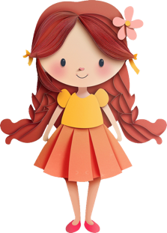
Paper Castle Tracker: ‘Learn to Read’ & ‘Learn to Spell’ for ____________________
Student | Date

